**CB[1] – Using Software Cortland Watson**

**Type in your score here 🡪 __25__ out of 25 points possible**

1. (5 points) Ponder/Reflect Exercise – Reflect on what you have learned from this portion of the class. Examples of what you can do are: a brief outline of material covered, insights you gained from class or personal study, or items you feel that you need to follow up or work on. (3-5 sentences)
   1. This week I have been able to learn the importance of blocking and I have been able to learn why it is important. We are able to control for nuisance variables by using this system. At the same time, we are able to see if blocking is useful by running test that both include and exclude the blocking variable so that we are able to see the comparison.
2. (a) Use the file marketing.txt from the homework page. The first column is sales of a product of interest (in dollars), the second column is the shelf height factor (shelf height for the product being sold), and the third column is day of week (the blocking factor). On each day, the researcher in this study randomly assigned a product of interest to a location on a five-level store shelf and then recorded the total sales for each shelf at the end of the day. Our primary interest is to see if the shelf heights have different mean sales. Use one of the following software: SAS or R to analyze the data and do the following:
   1. (5 points) Check the assumption of equal variance and residuals being normally distributed using a software.
      1. 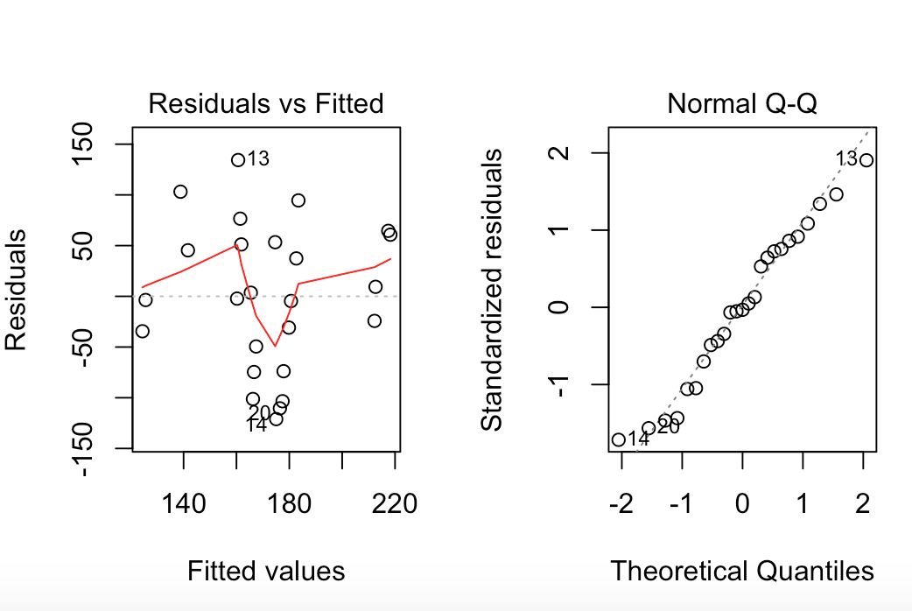
      2. This does not look good when we are considering the equal variance of the data. The normality of the data looks promising, even though it has a slight tail at the top. The variance plot shows us that there is a lot of inconsistency in the spread of the data.
   2. (4 points) Get an ANOVA table using using two software.
      1. 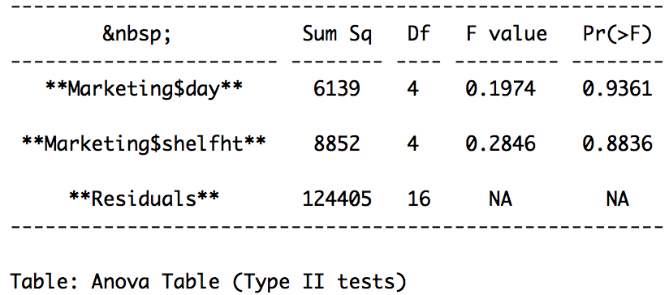
   3. (5 points) For effect of interest: i) state the null and alternative hypotheses, ii) give the test statistic, iii) give the degrees of freedom, iv) state the p-value, v) determine whether you should reject or not reject the null hypothesis, and vi) write a sentence which gives an appropriate conclusion.
      1. Null is that the means of the groups are 0. The alternative hypothesis is that one of the groups is not 0.
      2. The test statistic is
         1. Day=0.1974
         2. Shelf Height=0.2846
      3. DF
         1. Numerator Day = 4
         2. Numerator Shelf Height = 4
         3. Denominator Residuals = 16
      4. P-value
         1. Day = 0.9361
         2. Shelf Height = 0.8836
      5. We do not have sufficient evidence to reject the null hypothesis.
      6. Based on our analysis, shelf height does not make any difference on the sale of an item.
   4. (2 points) Does the blocking factor turn out to be an important source of variability?
      1. 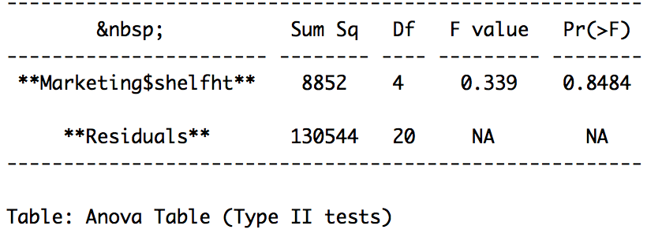
      2. First, the day variable did not have significance when run through the test. This means that the block was not effective. Second, when we run the test excluding the day factor, we get almost the same results. Therefore it is safe to conclude that the blocking factor did not do what we were hoping.
   5. (4 points) Now ignore the blocks and re-run the analysis as a BF[1] design using either R or SAS. What are the degrees of freedom for the F distribution used to test for shelf height? How do your conclusions change? Why are the results different from the CB[1] analysis?
      1. 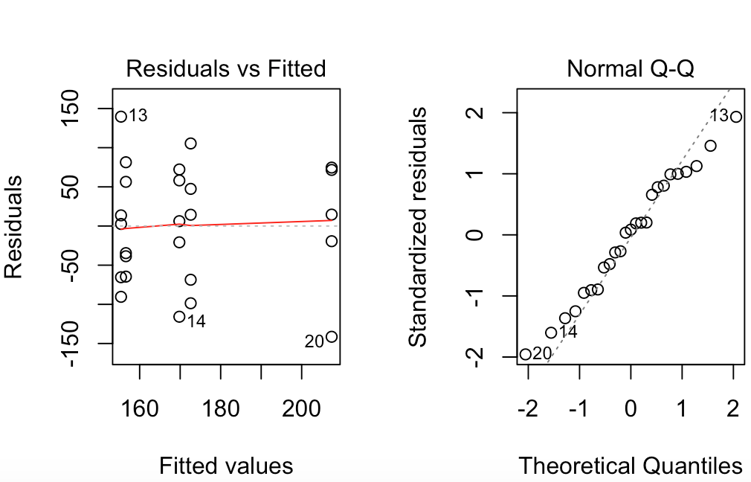
         1. This looks a lot better when we consider the spread of the data, although it is not perfect. Secondly, the normality is a little more skewed in this data analysis than in the previous.
      2. 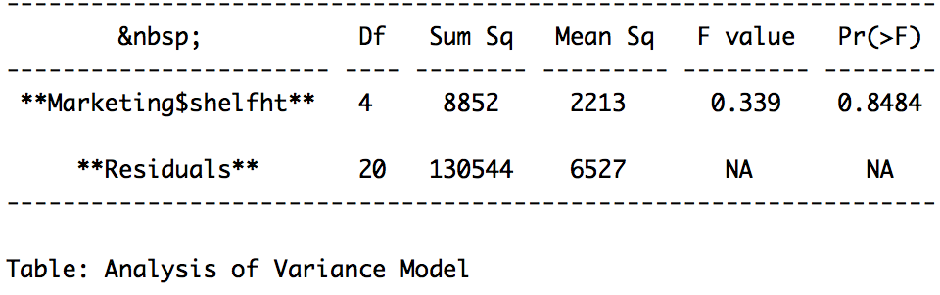
         1. In the second analysis we are able to see that the degrees of freedom change. The numerator is 4, but the denominator is 20, since we are not using some of them for the blocking variable. We still have insufficient evidence to reject the null, stating that shelf height has no effect on the sale of an item.